Coupling OG-Core and OSeMOSYS/CLEWs
A technical mapping of how each model's outputs can be translated into inputs for the other in a coupled OG–CLEWs architecture
Prepared as an implementation note based on the official OG-Core and OSeMOSYS documentation
Accessed April 21, 2026

Interpretation note. The mappings in this document are implementation recommendations inferred from the documented variables, parameters, and equations of the two models. They are not native one-to-one links supplied by either codebase. A bridge layer is required to translate units, timing, ownership, incidence, and price concepts.

Executive summary
OG-Core and OSeMOSYS solve different parts of the policy problem. OG-Core is a dynamic overlapping-generations general-equilibrium model with households, industries, government, public capital, debt, taxes, and prices. OSeMOSYS is a least-cost system model defined over REGION, TECHNOLOGY, FUEL, TIMESLICE, YEAR, MODE_OF_OPERATION, and EMISSION. In a CLEWs implementation, those technologies and fuels can also represent water, land, irrigation, storage, food-system services, and other physical-resource processes.
Because of that mismatch, the models should not be connected by literal variable substitution. The correct architecture is a bridge layer that converts OSeMOSYS physical outputs and annual cash flows into macro-fiscal wedges OG-Core can absorb, and converts OG-Core demand, financing, and policy paths into exogenous annual inputs and constraints that OSeMOSYS can optimize over.

The six exchange objects that matter most in a practical coupling
Exchange object | Why it is the core coupling object
Annual end-use demand | OG-Core determines household, industry, public-service, and investment-related demand levels that OSeMOSYS/CLEWs must satisfy through SpecifiedAnnualDemand and related activity requirements.
Delivered cost schedules | OSeMOSYS system costs need to be translated into annual unit-cost wedges by fuel or service before OG-Core can represent them through consumption taxes, producer cost wedges, tariff compensation, or productivity/reliability effects.
Public capital expenditure | Publicly financed technology and storage investment is the cleanest route from OSeMOSYS into OG-Core's I_g, alpha_I, and K_g path.
Private capital expenditure | Privately financed build-out should feed OG-Core as investment demand and, where possible, sectoral capital-demand changes.
Emissions and policy revenues | OSeMOSYS provides physical emissions and emissions-penalty cash flows; OG-Core uses those quantities for fiscal closure, recycling rules, and welfare analysis.
Financing envelopes and legacy capacity | OG-Core determines what is fiscally feasible; OSeMOSYS uses that information through capacity ceilings, activity limits, and residual-capacity assumptions.

Figure 1. How the bridge layer works
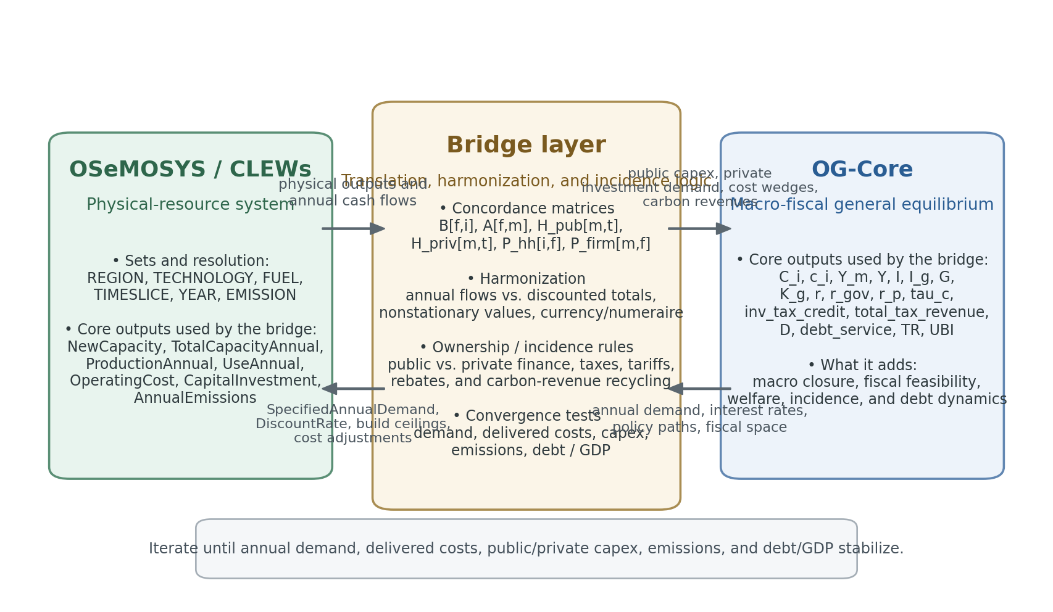
The bridge layer sits between the engineering/resource model and the macro-fiscal model. It harmonizes time resolution, units, ownership, price incidence, and fiscal treatment, then iterates until a stable coupled path is reached.
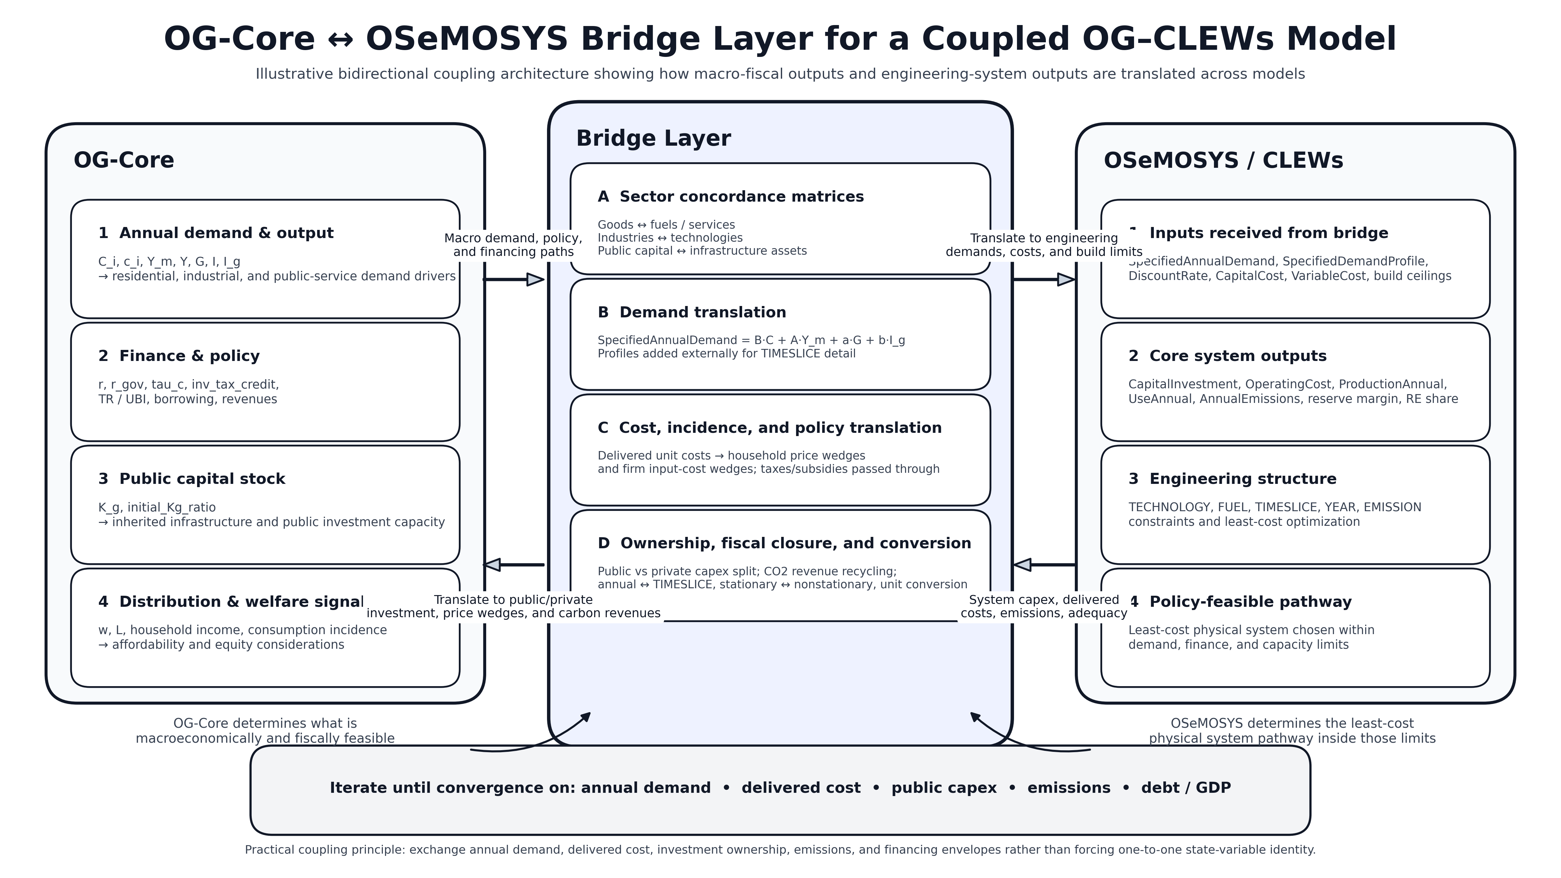

1. Why a bridge layer is required
Four mismatches make a direct one-to-one merge impossible:
- Representation mismatch: OSeMOSYS is technology, fuel, and time-slice based, whereas OG-Core is organized around households, production industries, consumption goods, and a government budget constraint.
- Time mismatch: OSeMOSYS is explicit about TIMESLICE structure, while OG-Core is annual and internally solves a stationarized equilibrium before converting back to nonstationary values.
- Cost mismatch: OSeMOSYS minimizes TotalDiscountedCost over the model horizon, but OG-Core requires annual flow variables for each period's resource constraint and fiscal closure.
- Incidence mismatch: OSeMOSYS does not by itself decide whether a cost lands on households, firms, or the public budget, while OG-Core welfare and debt results depend critically on that incidence choice.
The practical consequence is that the coupling should revolve around a small number of bridge objects rather than every raw variable in either model. Those bridge objects are annual demand, delivered service costs, public capex, private capex, emissions and policy revenues, financing envelopes, and inherited capacity/public-capital stocks.

2. OSeMOSYS/CLEWs → OG-Core mapping
This direction translates OSeMOSYS’s technology build-out, operating costs, emissions, and system-adequacy outcomes into macro-fiscal objects that OG-Core can solve over. The recommended rule is: pass annual physical consequences and annual cash-flow consequences forward, but do not overwrite OG-Core's structural parameters or equilibrium prices directly.
OSeMOSYS/CLEWs source-side object(s) | Bridge transformation | OG-Core destination input or usage | What it does inside OG-Core | Key cautions
CapitalInvestment[r,t,y]  CapitalInvestmentStorage[r,s,y]  NewCapacity[r,t,y]  TotalCapacityAnnual[r,t,y] | Split by ownership first, then map public technologies and storage through concordance matrices H_pub[m,t] and H_stor_pub[m,s] into industry-level public infrastructure investment. | I_g  alpha_I  K_g  initial_Kg_ratio | Builds the government-infrastructure path and public-capital stock law of motion that affects production, the budget, and long-run output. | Use annual flows, not discounted totals. Only the publicly financed share should feed I_g.
CapitalInvestment[r,t,y]  NewCapacity[r,t,y]  TotalCapacityAnnual[r,t,y] | Map privately financed technologies through H_priv[m,t] or collapse them into economy-wide investment demand if OG-Core sector detail is coarse. | I  K_m  sectoral investment demand | Adds private system build-out to the demand for investment goods and, where feasible, to sectoral capital demand. | Do not force a one-for-one technology = industry identity if the OG-Core sector structure is too aggregated.
OperatingCost[r,t,y]  AnnualVariableOperatingCost  AnnualFixedOperatingCost  ProductionAnnual[r,f,y]  UseAnnual[r,f,y] | Construct annual delivered unit-cost schedules by fuel or service, then apply incidence matrices P_hh[i,f] and P_firm[m,f] to build household and firm cost wedges. | tau_c-consistent consumption wedges  producer input-cost wedges  induced effects on p_i, p_tilde, p_m through equilibrium | Lets OG-Core capture tariff changes, resource-cost shocks, subsidy needs, and competitiveness effects while still solving its own general equilibrium. | Do not directly overwrite OG-Core price variables; pass wedges and let equilibrium determine prices.
AnnualTechnologyEmission[r,t,e,y]  AnnualEmissions[r,e,y]  AnnualTechnologyEmissionPenaltyByEmission  AnnualTechnologyEmissionsPenalty | Keep the physical emissions path for target tracking; translate emissions-penalty cash flows into a carbon-tax or emissions-charge revenue stream and specify a recycling rule. | total_tax_revenue add-on  TR / UBI / I_g recycling  consumption or producer tax wedges | Allows OG-Core to evaluate fiscal incidence, debt effects, and welfare under carbon pricing or shadow-price scenarios. | OG-Core has no native engineering-emissions block, so quantities and fiscal treatment must be carried separately.
TotalCapacityAnnual  CapacityFactor  AvailabilityFactor  TotalCapacityInReserveMargin  DemandNeedingReserveMargin  TotalREProductionAnnual | Translate adequacy, reliability, and renewable-share outcomes into scarcity-cost wedges, reliability/provision wedges, or productivity shocks for affected sectors. | Z or other effective productivity/cost wedges  selected producer cost adjustments | Captures the macro relevance of reliability and tightness in the physical system without embedding dispatch directly in OG-Core. | Do not use these outputs to recalibrate OG-Core structural production parameters unless you are doing a separate re-estimation exercise.
TradeAnnual[r,rr,f,y]  UseAnnual and ProductionAnnual by fuel | Convert net import dependence into delivered-cost effects, import-bill assumptions, or financing needs; optionally feed those into open-economy financing scenarios. | cost wedges  financing assumptions  world-interest-rate scenario context | Represents exposure to imported fuels or commodities even though OG-Core's external block is about debt and capital flows rather than detailed goods trade. | There is no direct one-to-one goods-trade balance object in baseline OG-Core.
TotalDiscountedCost[r,y]  ModelPeriodCostByRegion[r] | Use only as scenario-comparison diagnostics, not as budget inputs. | reporting / scenario ranking only | Helps compare alternative technology pathways outside OG-Core's annual flow equations. | Do not put discounted horizon totals directly into OG-Core's annual resource or budget constraints.

3. OG-Core → OSeMOSYS/CLEWs mapping
This direction translates OG-Core’s macro demand, financing conditions, tax policy, fiscal space, and inherited public capital into the annual exogenous inputs and constraints OSeMOSYS needs. The recommended rule is: OG-Core sets the macro environment that the system model must live inside; OSeMOSYS then chooses the least-cost technology mix within that environment.
OSeMOSYS/CLEWs source-side object(s) | Bridge transformation | OG-Core destination input or usage | What it does inside OG-Core | Key cautions
C_i  c_i[s,j] | Apply a concordance matrix B[f,i] from OG-Core consumption goods to OSeMOSYS fuels or services; optionally build demands at household-group level before aggregation. | SpecifiedAnnualDemand[r,f,y] | Drives residential electricity, cooking, water-service, food-service, or mobility demand in the system model. | This is the cleanest direct demand mapping from OG-Core into OSeMOSYS.
Y_m  Y  I  I_g  G | Use activity matrices A[f,m] plus public-service and investment coefficients to derive non-household service demand: industrial energy, irrigation pumping, freight, public-service loads, construction-related demand, and other CLEWs commodities. | SpecifiedAnnualDemand and/or exogenous service-demand series  possibly AccumulatedAnnualDemand where relevant | Lets sectoral output and public/investment activity determine productive demand instead of treating all demand as household demand. | OG-Core is annual; any time-slice structure still has to be added separately.
No native OG-Core time-slice output | Import or estimate external load shapes, irrigation calendars, seasonal water profiles, or mobility profiles, then combine them with OG-Core annual demand totals. | SpecifiedDemandProfile[r,f,l,y] | Supplies the within-year profile OSeMOSYS needs to translate annual demand into RateOfDemand by TIMESLICE. | This input cannot be generated directly by OG-Core because OG-Core is not a time-slice model.
r  r_gov  r_p  world_int_rate_annual | Choose a financing rule: either pass a region-level discount rate, or embed financing conditions in adjusted technology-specific CapitalCost schedules. | DiscountRate[r]  finance-adjusted CapitalCost[r,t,y] | Links macro interest rates and sovereign/private financing conditions to the relative attractiveness of long-lived technologies. | Standard OSeMOSYS has a region-level DiscountRate, so different public/private financing regimes usually need scenario logic outside the core formulation.
tau_c  inv_tax_credit  cit_rate | Translate taxes and subsidies into effective technology economics: consumption/excise taxes to VariableCost, investment credits to CapitalCost reductions, and business-tax changes to after-tax capital-cost markups when relevant. | VariableCost  CapitalCost  EmissionsPenalty or other policy-cost adjustments | Lets OSeMOSYS optimize under the same policy package that OG-Core is evaluating for fiscal and welfare effects. | Map only policies with a clear engineering-cost interpretation; personal-income-tax schedules usually affect demand or adoption indirectly rather than as direct OSeMOSYS parameters.
total_tax_revenue  D  new_borrowing  debt_service  alpha_I  debt_ratio_ss | Construct an annual public-investment envelope B_pub[y] and push it into technology-specific ceilings or activity limits. | TotalAnnualMaxCapacityInvestment  TotalAnnualMaxCapacity  TotalTechnologyAnnualActivityUpperLimit | Imposes macro-fiscal feasibility on the least-cost build path. | This is the core fiscal-closure link from OG-Core to OSeMOSYS.
K_g  initial_Kg_ratio | Disaggregate public capital into technology-level legacy assets such as grid components, dams, canals, pumping stations, treatment plants, and storage facilities. | ResidualCapacity  ResidualStorageCapacity | Makes inherited infrastructure explicit on the system side before new investment is optimized. | Requires a technology concordance because OG-Core public capital is industry-level, not technology-level.
w  L  n  TR  UBI  before_tax_income  hh_taxes | Use an external affordability/adoption module or scenario rules to convert these outputs into uptake assumptions, activity caps, or differentiated demand elasticities. | outside-core adoption module  scenario-specific activity caps or demand adjustments | Extends the coupling to affordability, distribution, and policy acceptance without trying to force those concepts into OSeMOSYS engineering coefficients. | Do not overwrite InputActivityRatio, OutputActivityRatio, CapacityFactor, AvailabilityFactor, or OperationalLife with these macro variables.

4. Recommended bridge transformations
A practical coupling is easiest to implement with a small set of concordance matrices and annual translation formulas. The equations below are not native to either codebase; they are a recommended interface layer that respects the documented model structures.
4.1 Demand translation
SpecifiedAnnualDemand[r,f,y] = sum_i B[f,i]*C_i[y]
+ sum_m A[f,m]*Y_m[y]
+ a[f]*G[y] + b[f]*I_g[y]

B[f,i] maps OG-Core consumption goods to OSeMOSYS fuels or services, while A[f,m] maps industry output to productive demand. The coefficients a[f] and b[f] capture public-service loads and infrastructure/construction-related demand.
4.2 Public-capex translation
I_g_OG[m,y] = sum_t H_pub[m,t]*CapitalInvestment[r,t,y]
+ sum_s H_stor_pub[m,s]*CapitalInvestmentStorage[r,s,y]

alpha_I[y] = (sum_m I_g_OG[m,y]) / Y[y]

Only the publicly financed share should enter this mapping. The resulting I_g path then updates K_g in OG-Core through its own public-capital law of motion.
4.3 Delivered-cost translation
uc[f,y] = sum_{t in T_f}(OperatingCost[t,y] + EmissionsPenalty[t,y]
+ chi[t]*CapitalInvestment[t,y]) / DeliveredQuantity[f,y]

Delta_p_i[y] = sum_f P_hh[i,f] * Delta_uc[f,y]
Delta_inputcost_m[y] = sum_f P_firm[m,f]* Delta_uc[f,y]

This generates annual unit-cost schedules by fuel or service. Those schedules should enter OG-Core as wedges on household consumption, producer input costs, or tariff-compensation needs, not as direct replacements for equilibrium prices.
4.4 Carbon-revenue translation
Rev_CO2[y] = sum_{t,e} AnnualTechnologyEmissionPenaltyByEmission[t,e,y]

Rev_CO2 can then be recycled in OG-Core through transfers, UBI-style rebates, lower debt, or additional public investment, depending on the policy experiment.
4.5 Fiscal-envelope translation back to OSeMOSYS
sum_{t in T_pub} CapitalInvestment[r,t,y] <= B_pub[y]

B_pub[y] is built from OG-Core revenue, transfers, debt-service, borrowing, and fiscal-rule outputs. In OSeMOSYS, it is typically implemented through technology-specific TotalAnnualMaxCapacityInvestment, TotalAnnualMaxCapacity, or annual activity limits.

5. Iterative solution algorithm
- Run a baseline OG-Core path and export annual nonstationary series for C_i, Y_m, Y, I, I_g, G, K_g, r, r_gov, tax-policy paths, debt, and any transfer/rebate rules.
- Translate those outputs into OSeMOSYS demand series, SpecifiedDemandProfile assumptions, DiscountRate or finance-adjusted CapitalCost schedules, and public/private build ceilings.
- Run OSeMOSYS/CLEWs and export annual technology build-out, operating costs, production and use by fuel/service, emissions, emissions-penalty cash flows, reserve/renewable indicators, and any trade flows that materially affect delivered costs.
- Translate those OSeMOSYS results back into OG-Core public capex, private investment demand, delivered-cost wedges, carbon revenues, and any reliability/productivity or scarcity wedges.
- Re-solve OG-Core with the updated wedges and financing consequences, then refresh the annual demand and fiscal-feasibility inputs for OSeMOSYS.
- Iterate until a stable set of bridge objects is reached: annual demand, delivered unit costs, public/private capex, emissions, and debt/GDP.

6. Guardrails and non-mappings
Guardrail 1 — Use annual flow variables for coupling into OG-Core.
OSeMOSYS TotalDiscountedCost and ModelPeriodCostByRegion are useful for scenario ranking, but OG-Core budget and resource constraints require annual flow variables such as CapitalInvestment, OperatingCost, and annual emissions penalties.

Guardrail 2 — Respect stationarization and nonstationary values.
OG-Core solves a stationarized equilibrium and then converts results back to nonstationary values. The bridge should pass nonstationary annual paths into OSeMOSYS, or explicitly convert OSeMOSYS annual flows into stationary units before solving OG-Core.

Guardrail 3 — Maintain an explicit price/unit conversion layer.
OG-Core normalizes the price of industry M output to 1, while OSeMOSYS monetary units are user-defined engineering cost units. Do not directly transplant nominal values without a currency and numeraire conversion rule.

Guardrail 4 — Keep structural parameters model-specific unless you are recalibrating.
Do not use OSeMOSYS outputs to overwrite OG-Core structural parameters such as gamma, gamma_g, epsilon, frisch, beta_annual, or sigma. Do not use OG-Core macro outputs to overwrite OSeMOSYS engineering parameters such as InputActivityRatio, OutputActivityRatio, CapacityFactor, AvailabilityFactor, or OperationalLife.

Guardrail 5 — Handle ownership and incidence explicitly.
Every investment, tariff, subsidy, or emissions charge should be allocated to households, firms, or government before it is passed across models. That ownership/incidence split is where most coupled-model errors arise.

In short: OSeMOSYS should give OG-Core the annual physical-system consequences and annual cash-flow consequences of a technology pathway; OG-Core should give OSeMOSYS the annual demand, financing conditions, fiscal space, and policy environment that pathway must live inside.

References used for variable and parameter names
- OG-Core documentation — Model variables: https://pslmodels.github.io/OG-Core/content/intro/variables.html
- OG-Core documentation — Model parameters: https://pslmodels.github.io/OG-Core/content/intro/parameters.html
- OG-Core documentation — Equilibrium: https://pslmodels.github.io/OG-Core/content/theory/equilibrium.html
- OSeMOSYS documentation — Structure of OSeMOSYS: https://osemosys.readthedocs.io/en/latest/manual/Structure%20of%20OSeMOSYS.html

